Project Design Phase-II

Data Flow Diagram & User Stories

|  |  |
| --- | --- |
| Date | 03 October 2022 |
| Team ID | PNT2022TMID25996 |
| Project Name | Intelligent Vehicle Damage Assessment & Cost Estimator for Insurance Companies |
| Maximum Marks | 4 Marks |

# Data Flow Diagrams:

A Data Flow Diagram (DFD) is a traditional visual representation of the information flows within a system. A neat and clear DFD can depict the right amount of the system requirement graphically. It shows how data enters and leaves the system, what changes the information, and where data is stored.

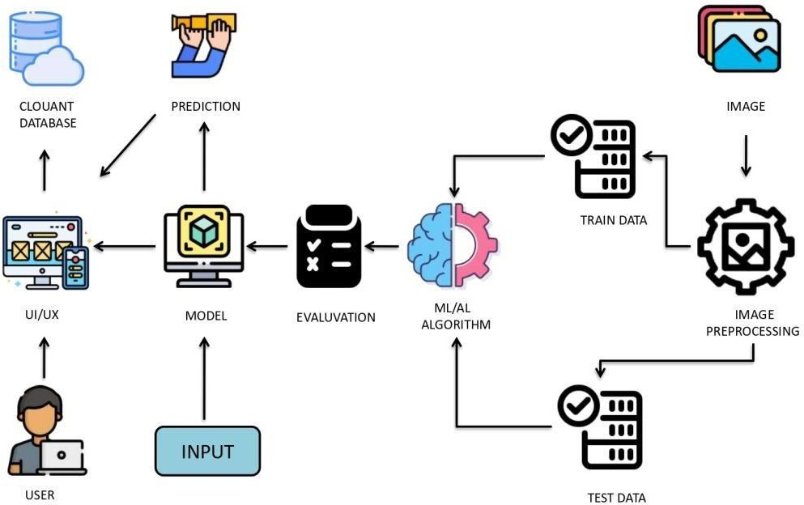

# Flowchart:

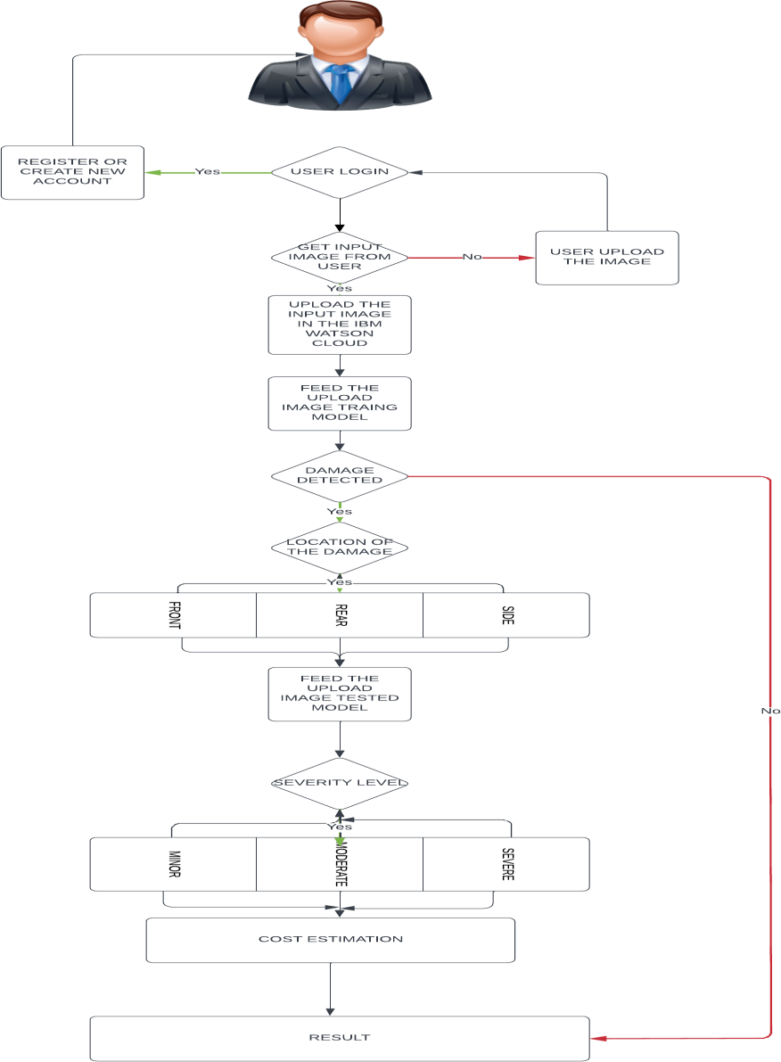

**User Stories**

Use the below template to list all the user stories for the product.

|  |  |  |  |  |  |  |
| --- | --- | --- | --- | --- | --- | --- |
| **User Type** | **Functional**  **Requirement (Epic)** | **User Story Number** | **User Story / Task** | **Acceptance criteria** | **Priority** | **Release** |
| Customer (Mobile user) | Registration | USN-1 | As a user, I can register for the application by entering my email, password, and confirming my password. | I can access my account / dashboard by entering valid credentails | High | Sprint-1 |
| Customer Details | Login | USN-2 | As a user, I will receive confirmation email once I have registered for the application | I can receive confirmation email & click confirm | High | Sprint-1 |
| Customer Uses | Dashboard | USN-3 | As a user, I can register for the application through Facebook | I can register & access the dashboard with Facebook  Login | Low | Sprint-4 |
| Customer Options | Details about insurance companies | USN-4 | As a user, I can register for the application through Gmail | I can register & access the dashboard with Facebook Gmail | Medium | Sprint-1 |
| Customer usage | Login | USN-5 | As a user, I can log into the application by entering email & password | I can log in and view my dashboard at my demand  on any time | High | Sprint-1 |
| Customer needs to do | Dashboard | USN-6 | As a user I must capture images of my vehicle and upload it into the web portal | I can capture the entire vehicle and upload | High | Sprint-2 |
| Customer (Web user) | Details about  estimated cost based on damage | USN-7 | As a user I must receive a detailed report of  the damages present in the vehicle and the cost estimated | I can get the estimated insurance cost | High | Sprint-3 |
| Customer Care Executive | Details about Estimated cost Based on damage | USN-8 | As a user, I need to get support from developers in case of queries and failure of service provided | I can have smooth user experiences and all the issues raised is sorted | Medium | Sprint-4 |
| Administrator | Details about Estimated cost Based on damage | USN-9 | We need to satisfy the customer needs in an efficient way and make sure any sort of errors are fixed | I can finish the work without any problems | High | Sprint-4 |